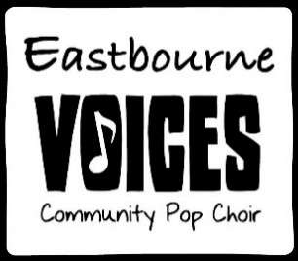

Livin’ on a prayer

Tommy used to work on the docks  
Union's been on strike, he's down on his luck  
It's tough, so tough  
Gina works the diner all day  
Working for her man, she brings home her pay for love  
Ooh, for love  
  
She says, "We've gotta hold on to what we've got  
It doesn't make a difference if we make it or not  
We've got each other and that's a lot for love  
We'll give it a shot"  
  
Whoa, we're half way there  
Whoa, livin' on a prayer  
Take my hand, we'll make it I swear  
Whoa, livin' on a prayer  
  
Tommy's got his six-string in hock  
Now he's holding in what he used to make it talk  
So tough, ooh, it's tough  
Gina dreams of running away  
When she cries in the night, Tommy whispers  
"Baby it's okay, someday"

We've gotta hold on to what we've got  
It doesn't make a difference if we make it or not  
We've got each other and that's a lot for love  
We'll give it a shot  
  
Whoa, we're half way there  
Whoa, livin' on a prayer  
Take my hand, we'll make it I swear  
Whoa, livin' on a prayer  
Livin' on a prayer

Ooh, we've gotta hold on, ready or not  
You live for the fight when that's all that you've got  
  
Whoa, we're half way there  
Whoa, livin' on a prayer  
Take my hand and we'll make it I swear  
Whoa, livin' on a prayer  
  
Whoa, we're half way there  
Whoa, livin' on a prayer  
Take my hand and we'll make it I swear  
Whoa, livin' on a prayer  
  
Whoa, we're half way there  
Whoa, livin' on a prayer  
Take my hand and we'll make it I swear  
Whoa, livin' on a prayer  
  
Livin' on a prayer